**PRACTICAL 5**

**AIM:**  To create the following topology.

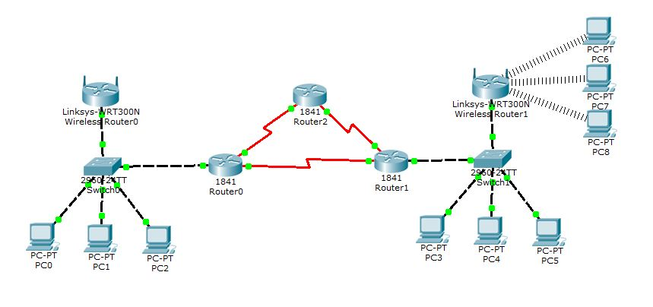

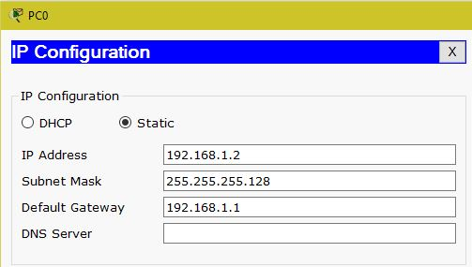

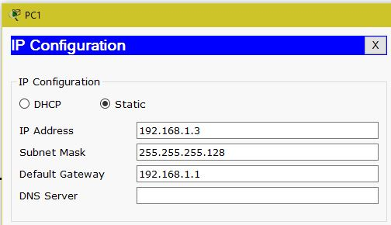

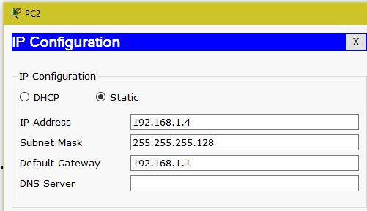

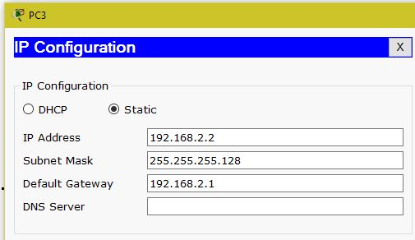

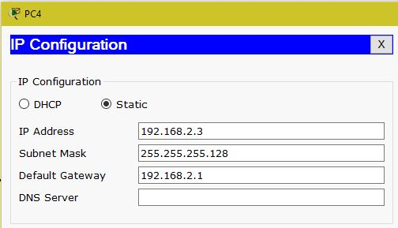

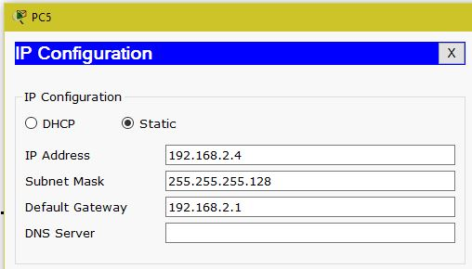

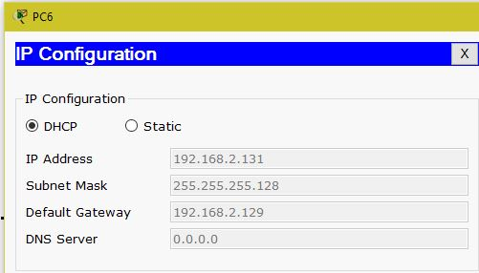

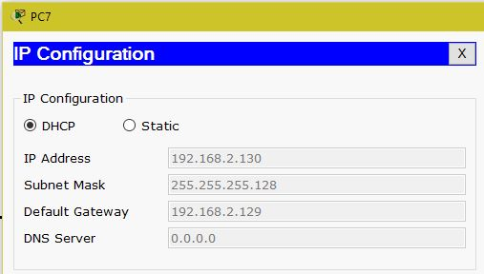

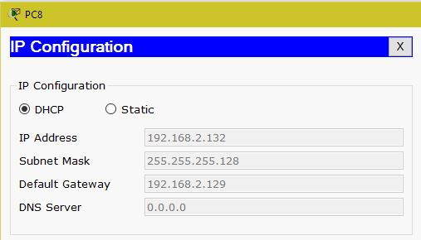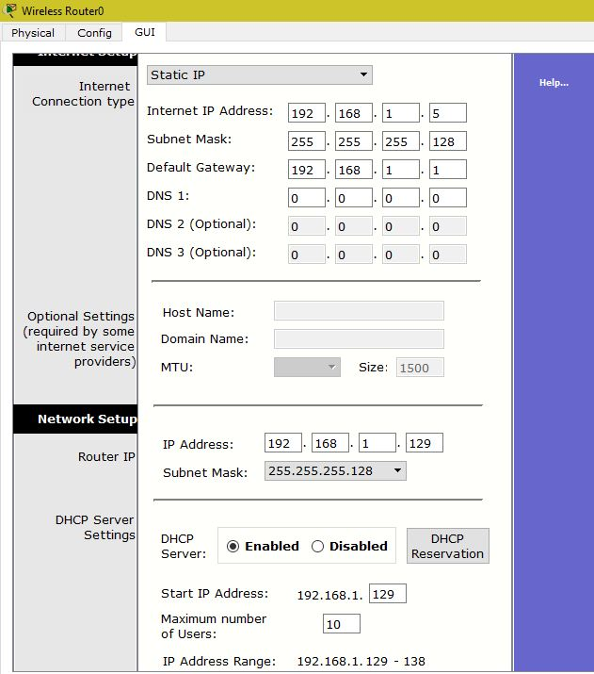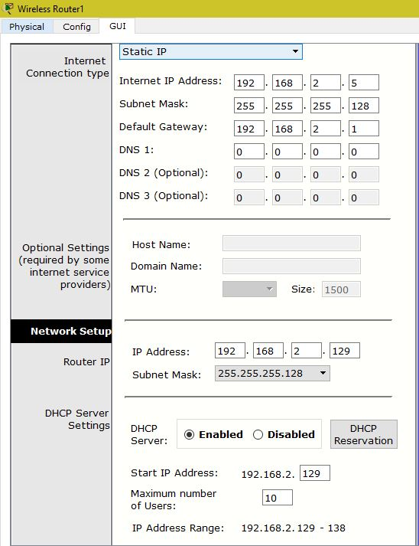

**Router0:**

Router>enable

Router#configure terminal

Enter configuration commands, one per line. End with CNTL/Z.

Router(config)#interface FastEthernet0/0

Router(config-if)#ip address 192.168.1.1 255.255.255.128

Router(config-if)#no shutdown

Router(config-if)#

%LINK-5-CHANGED: Interface FastEthernet0/0, changed state to up

%LINEPROTO-5-UPDOWN: Line protocol on Interface FastEthernet0/0, changed state to up

Router(config-if)#exit

Router(config)#interface Serial0/1/0

Router(config-if)#ip address 192.168.3.1 255.255.255.0

Router(config-if)#clock rate 72000

Router(config-if)#no shutdown

Router(config-if)#

Router(config-if)#exit

Router(config)#interface Serial0/1/1

Router(config-if)#ip address 192.168.4.1 255.255.255.0

Router(config-if)#clock rate 72000

Router(config-if)#no shutdown

**Router1:**

Router>enable

Router#configure terminal

Enter configuration commands, one per line. End with CNTL/Z.

Router(config)#interface FastEthernet0/0

Router(config-if)#ip address 192.168.2.1 255.255.255.128

Router(config-if)#no shutdown

Router(config-if)#

%LINK-5-CHANGED: Interface FastEthernet0/0, changed state to up

%LINEPROTO-5-UPDOWN: Line protocol on Interface FastEthernet0/0, changed state to up

Router(config-if)#exit

Router(config)#interface Serial0/1/0

Router(config-if)#ip address 192.168.3.2 255.255.255.0

Router(config-if)#clock rate 72000

This command applies only to DCE interfaces

Router(config-if)#no shutdown

Router(config-if)#

%LINK-5-CHANGED: Interface Serial0/1/0, changed state to up

Router(config-if)#exit

Router(config)#interface Serial0/1/1

Router(config-if)#ip address 192.168.5.1 255.255.255.0

Router(config-if)#

%LINEPROTO-5-UPDOWN: Line protocol on Interface Serial0/1/0, changed state to up

clock rate 72000

This command applies only to DCE interfaces

Router(config-if)#no shutdown

**Router2:**

Router>enable

Router#configure terminal

Enter configuration commands, one per line. End with CNTL/Z.

Router(config)#interface Serial0/1/0

Router(config-if)#ip address 192.168.5.2 255.255.255.0

Router(config-if)#clock rate 72000

This command applies only to DCE interfaces

Router(config-if)#no shutdown

Router(config-if)#

%LINK-5-CHANGED: Interface Serial0/1/0, changed state to up

Router(config-if)#exit

Router(config)#interface Serial0/1/1

Router(config-if)#ip address 192.168.4.2 255.255.255.0

Router(config-if)#

%LINEPROTO-5-UPDOWN: Line protocol on Interface Serial0/1/0, changed state to up

clock rate 72000

This command applies only to DCE interfaces

Router(config-if)#no shutdown

Router(config-if)#

%LINK-5-CHANGED: Interface Serial0/1/1, changed state to up

%LINEPROTO-5-UPDOWN: Line protocol on Interface Serial0/1/1, changed state to up

**IP Routes:**

**Router0:**

Router(config)#router rip

Router(config-router)#network 192.168.1.0

Router(config-router)#network 192.168.3.0

Router(config-router)#network 192.168.4.0

**Router1:**

Router(config)#router rip

Router(config-router)#network 192.168.2.0

Router(config-router)#network 192.168.3.0

Router(config-router)#network 192.168.5.0

**Router2:**

Router(config)#router rip

Router(config-router)#network 192.168.4.0

Router(config-router)#network 192.168.5.0

**Output:**

